CSA5116 Cryotography and network security
Name:P.S.Surabhi Surya
Reg No:192421267
Lab Programs - Cycle 2
EX. NO: 11 IMPLEMENTATION OF DES
AIM:
To write a Python program to implement the Data Encryption Standard (DES) algorithm from first principles.
DESCRIPTION:
DES is a symmetric-key block cipher standardized by NIST that encrypts data in 64-bit blocks using a 56-bit effective key (from a 64-bit key, 8 bits of which are parity bits). It repeatedly applies an initial permutation and 16 Feistel rounds - each built from expansion, key mixing, S-box substitution and permutation - followed by a final permutation to transform the plain text block into the cipher text block. The same key, with the round subkeys applied in reverse order, is used to decrypt.
ALGORITHM:
STEP-1: Read the plain text message and the 64-bit secret key from the user.
STEP-2: Apply the Initial Permutation (IP) to each 64-bit block of the (padded) plain text.
STEP-3: Generate sixteen 48-bit round subkeys from the key using PC-1, the left-shift schedule and PC-2, then run 16 Feistel rounds (expansion, XOR with subkey, S-box substitution, P-permutation) on the block.
STEP-4: Apply the Final Permutation (Inverse IP) to obtain the cipher text block, and repeat for every block of the message.
STEP-5: To decrypt, repeat the same process using the subkeys in reverse order, then remove the padding to recover the original message.
PROGRAM: (Implementation of DES - Python)
# Experiment No: 11
# Implementation of DES (Data Encryption Standard)

IP = [58,50,42,34,26,18,10,2,60,52,44,36,28,20,12,4,
62,54,46,38,30,22,14,6,64,56,48,40,32,24,16,8,
57,49,41,33,25,17,9,1,59,51,43,35,27,19,11,3,
61,53,45,37,29,21,13,5,63,55,47,39,31,23,15,7]
FP = [40,8,48,16,56,24,64,32,39,7,47,15,55,23,63,31,
38,6,46,14,54,22,62,30,37,5,45,13,53,21,61,29,
36,4,44,12,52,20,60,28,35,3,43,11,51,19,59,27,
34,2,42,10,50,18,58,26,33,1,41,9,49,17,57,25]
E = [32,1,2,3,4,5,4,5,6,7,8,9,8,9,10,11,12,13,12,13,14,15,16,17,
16,17,18,19,20,21,20,21,22,23,24,25,24,25,26,27,28,29,28,29,30,31,32,1]
P = [16,7,20,21,29,12,28,17,1,15,23,26,5,18,31,10,
2,8,24,14,32,27,3,9,19,13,30,6,22,11,4,25]
PC1 = [57,49,41,33,25,17,9,1,58,50,42,34,26,18,
10,2,59,51,43,35,27,19,11,3,60,52,44,36,
63,55,47,39,31,23,15,7,62,54,46,38,30,22,
14,6,61,53,45,37,29,21,13,5,28,20,12,4]
PC2 = [14,17,11,24,1,5,3,28,15,6,21,10,23,19,12,4,26,8,
16,7,27,20,13,2,41,52,31,37,47,55,30,40,51,45,33,48,
44,49,39,56,34,53,46,42,50,36,29,32]
SHIFTS = [1,1,2,2,2,2,2,2,1,2,2,2,2,2,2,1]
SBOX = [
[[14,4,13,1,2,15,11,8,3,10,6,12,5,9,0,7],[0,15,7,4,14,2,13,1,10,6,12,11,9,5,3,8],
[4,1,14,8,13,6,2,11,15,12,9,7,3,10,5,0],[15,12,8,2,4,9,1,7,5,11,3,14,10,0,6,13]],
[[15,1,8,14,6,11,3,4,9,7,2,13,12,0,5,10],[3,13,4,7,15,2,8,14,12,0,1,10,6,9,11,5],
[0,14,7,11,10,4,13,1,5,8,12,6,9,3,2,15],[13,8,10,1,3,15,4,2,11,6,7,12,0,5,14,9]],
[[10,0,9,14,6,3,15,5,1,13,12,7,11,4,2,8],[13,7,0,9,3,4,6,10,2,8,5,14,12,11,15,1],
[13,6,4,9,8,15,3,0,11,1,2,12,5,10,14,7],[1,10,13,0,6,9,8,7,4,15,14,3,11,5,2,12]],
[[7,13,14,3,0,6,9,10,1,2,8,5,11,12,4,15],[13,8,11,5,6,15,0,3,4,7,2,12,1,10,14,9],
[10,6,9,0,12,11,7,13,15,1,3,14,5,2,8,4],[3,15,0,6,10,1,13,8,9,4,5,11,12,7,2,14]],
[[2,12,4,1,7,10,11,6,8,5,3,15,13,0,14,9],[14,11,2,12,4,7,13,1,5,0,15,10,3,9,8,6],
[4,2,1,11,10,13,7,8,15,9,12,5,6,3,0,14],[11,8,12,7,1,14,2,13,6,15,0,9,10,4,5,3]],
[[12,1,10,15,9,2,6,8,0,13,3,4,14,7,5,11],[10,15,4,2,7,12,9,5,6,1,13,14,0,11,3,8],
[9,14,15,5,2,8,12,3,7,0,4,10,1,13,11,6],[4,3,2,12,9,5,15,10,11,14,1,7,6,0,8,13]],
[[4,11,2,14,15,0,8,13,3,12,9,7,5,10,6,1],[13,0,11,7,4,9,1,10,14,3,5,12,2,15,8,6],
[1,4,11,13,12,3,7,14,10,15,6,8,0,5,9,2],[6,11,13,8,1,4,10,7,9,5,0,15,14,2,3,12]],
[[13,2,8,4,6,15,11,1,10,9,3,14,5,0,12,7],[1,15,13,8,10,3,7,4,12,5,6,11,0,14,9,2],
[7,11,4,1,9,12,14,2,0,6,10,13,15,3,5,8],[2,1,14,7,4,10,8,13,15,12,9,0,3,5,6,11]],
]

def permute(bits, table):
return [bits[i-1] for i in table]

def xor(a, b):
return [x ^ y for x, y in zip(a, b)]

def bytes_to_bits(b):
return [int(bit) for byte in b for bit in format(byte, '08b')]

def bits_to_bytes(bits):
out = bytearray()
for i in range(0, len(bits), 8):
byte = 0
for bit in bits[i:i+8]:
byte = (byte << 1) | bit
out.append(byte)
return bytes(out)

def generate_subkeys(key64):
key56 = permute(key64, PC1)
c, d = key56[:28], key56[28:]
subkeys = []
for shift in SHIFTS:
c = c[shift:] + c[:shift]
d = d[shift:] + d[:shift]
subkeys.append(permute(c + d, PC2))
return subkeys

def feistel(r, subkey):
x = xor(permute(r, E), subkey)
out = []
for i in range(8):
b6 = x[i*6:(i+1)*6]
row = b6[0]*2 + b6[5]
col = b6[1]*8 + b6[2]*4 + b6[3]*2 + b6[4]
out += [int(b) for b in format(SBOX[i][row][col], '04b')]
return permute(out, P)

def des_block(block8, key8, decrypt=False):
bits = permute(bytes_to_bits(block8), IP)
subkeys = generate_subkeys(bytes_to_bits(key8))
if decrypt:
subkeys = subkeys[::-1]
l, r = bits[:32], bits[32:]
for sk in subkeys:
l, r = r, xor(l, feistel(r, sk))
return bits_to_bytes(permute(r + l, FP))

def pad(data):
n = 8 - (len(data) % 8)
return data + bytes([n]) * n

def unpad(data):
return data[:-data[-1]]

def des_encrypt(message, key):
data = pad(message.encode())
return b"".join(des_block(data[i:i+8], key) for i in range(0, len(data), 8))

def des_decrypt(cipher, key):
data = b"".join(des_block(cipher[i:i+8], key, decrypt=True) for i in range(0, len(cipher), 8))
return unpad(data).decode()

key = bytes.fromhex("133457799BBCDFF1") # 64-bit (16 hex digit) secret key
message = input("Enter message to encrypt: ")
cipher = des_encrypt(message, key)
decrypted = des_decrypt(cipher, key)
print("\nDES Key (hex) :", key.hex().upper())
print("Encrypted (hex) :", cipher.hex().upper())
print("Decrypted message :", decrypted)
OUTPUT:
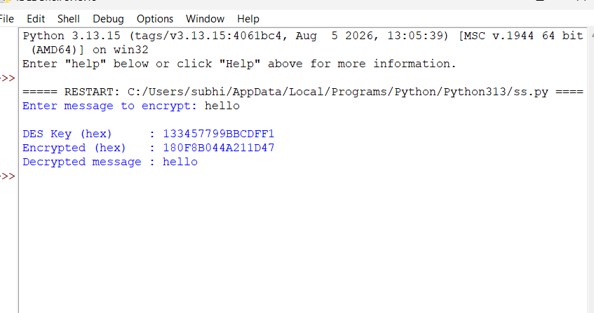
RESULT:
Thus the implementation of the DES algorithm was executed successfully using Python.

EX. NO: 12 IMPLEMENTATION OF 2DES
AIM:
To write a Python program to implement Double DES (2DES) encryption using two independent keys.
DESCRIPTION:
Double DES applies the DES algorithm twice in succession with two different 64-bit keys K1 and K2, so that the cipher text C = E(K2, E(K1, P)). It was proposed to strengthen single DES against brute-force key search, but in practice it offers little extra security over single DES because of the meet-in-the-middle attack, which can recover both keys in roughly the same effort as attacking a single DES key.
ALGORITHM:
STEP-1: Read the plain text message from the user, and fix two 64-bit keys K1 and K2.
STEP-2: Encrypt the plain text block using the DES algorithm with key K1 to obtain an intermediate cipher block.
STEP-3: Encrypt the intermediate block again using the DES algorithm with key K2 to obtain the final cipher text block.
STEP-4: Repeat Steps 2-3 for every 8-byte block of the (padded) message to build the complete cipher text.
STEP-5: To decrypt, first decrypt each cipher block with K2, then decrypt the result with K1, and remove the padding to recover the original message.
PROGRAM: (Implementation of 2DES - Python)
# Experiment No: 12
# Implementation of 2DES (Double DES)

IP = [58,50,42,34,26,18,10,2,60,52,44,36,28,20,12,4,
62,54,46,38,30,22,14,6,64,56,48,40,32,24,16,8,
57,49,41,33,25,17,9,1,59,51,43,35,27,19,11,3,
61,53,45,37,29,21,13,5,63,55,47,39,31,23,15,7]
FP = [40,8,48,16,56,24,64,32,39,7,47,15,55,23,63,31,
38,6,46,14,54,22,62,30,37,5,45,13,53,21,61,29,
36,4,44,12,52,20,60,28,35,3,43,11,51,19,59,27,
34,2,42,10,50,18,58,26,33,1,41,9,49,17,57,25]
E = [32,1,2,3,4,5,4,5,6,7,8,9,8,9,10,11,12,13,12,13,14,15,16,17,
16,17,18,19,20,21,20,21,22,23,24,25,24,25,26,27,28,29,28,29,30,31,32,1]
P = [16,7,20,21,29,12,28,17,1,15,23,26,5,18,31,10,
2,8,24,14,32,27,3,9,19,13,30,6,22,11,4,25]
PC1 = [57,49,41,33,25,17,9,1,58,50,42,34,26,18,
10,2,59,51,43,35,27,19,11,3,60,52,44,36,
63,55,47,39,31,23,15,7,62,54,46,38,30,22,
14,6,61,53,45,37,29,21,13,5,28,20,12,4]
PC2 = [14,17,11,24,1,5,3,28,15,6,21,10,23,19,12,4,26,8,
16,7,27,20,13,2,41,52,31,37,47,55,30,40,51,45,33,48,
44,49,39,56,34,53,46,42,50,36,29,32]
SHIFTS = [1,1,2,2,2,2,2,2,1,2,2,2,2,2,2,1]
SBOX = [
[[14,4,13,1,2,15,11,8,3,10,6,12,5,9,0,7],[0,15,7,4,14,2,13,1,10,6,12,11,9,5,3,8],
[4,1,14,8,13,6,2,11,15,12,9,7,3,10,5,0],[15,12,8,2,4,9,1,7,5,11,3,14,10,0,6,13]],
[[15,1,8,14,6,11,3,4,9,7,2,13,12,0,5,10],[3,13,4,7,15,2,8,14,12,0,1,10,6,9,11,5],
[0,14,7,11,10,4,13,1,5,8,12,6,9,3,2,15],[13,8,10,1,3,15,4,2,11,6,7,12,0,5,14,9]],
[[10,0,9,14,6,3,15,5,1,13,12,7,11,4,2,8],[13,7,0,9,3,4,6,10,2,8,5,14,12,11,15,1],
[13,6,4,9,8,15,3,0,11,1,2,12,5,10,14,7],[1,10,13,0,6,9,8,7,4,15,14,3,11,5,2,12]],
[[7,13,14,3,0,6,9,10,1,2,8,5,11,12,4,15],[13,8,11,5,6,15,0,3,4,7,2,12,1,10,14,9],
[10,6,9,0,12,11,7,13,15,1,3,14,5,2,8,4],[3,15,0,6,10,1,13,8,9,4,5,11,12,7,2,14]],
[[2,12,4,1,7,10,11,6,8,5,3,15,13,0,14,9],[14,11,2,12,4,7,13,1,5,0,15,10,3,9,8,6],
[4,2,1,11,10,13,7,8,15,9,12,5,6,3,0,14],[11,8,12,7,1,14,2,13,6,15,0,9,10,4,5,3]],
[[12,1,10,15,9,2,6,8,0,13,3,4,14,7,5,11],[10,15,4,2,7,12,9,5,6,1,13,14,0,11,3,8],
[9,14,15,5,2,8,12,3,7,0,4,10,1,13,11,6],[4,3,2,12,9,5,15,10,11,14,1,7,6,0,8,13]],
[[4,11,2,14,15,0,8,13,3,12,9,7,5,10,6,1],[13,0,11,7,4,9,1,10,14,3,5,12,2,15,8,6],
[1,4,11,13,12,3,7,14,10,15,6,8,0,5,9,2],[6,11,13,8,1,4,10,7,9,5,0,15,14,2,3,12]],
[[13,2,8,4,6,15,11,1,10,9,3,14,5,0,12,7],[1,15,13,8,10,3,7,4,12,5,6,11,0,14,9,2],
[7,11,4,1,9,12,14,2,0,6,10,13,15,3,5,8],[2,1,14,7,4,10,8,13,15,12,9,0,3,5,6,11]],
]

def permute(bits, table):
return [bits[i-1] for i in table]

def xor(a, b):
return [x ^ y for x, y in zip(a, b)]

def bytes_to_bits(b):
return [int(bit) for byte in b for bit in format(byte, '08b')]

def bits_to_bytes(bits):
out = bytearray()
for i in range(0, len(bits), 8):
byte = 0
for bit in bits[i:i+8]:
byte = (byte << 1) | bit
out.append(byte)
return bytes(out)

def generate_subkeys(key64):
key56 = permute(key64, PC1)
c, d = key56[:28], key56[28:]
subkeys = []
for shift in SHIFTS:
c = c[shift:] + c[:shift]
d = d[shift:] + d[:shift]
subkeys.append(permute(c + d, PC2))
return subkeys

def feistel(r, subkey):
x = xor(permute(r, E), subkey)
out = []
for i in range(8):
b6 = x[i*6:(i+1)*6]
row = b6[0]*2 + b6[5]
col = b6[1]*8 + b6[2]*4 + b6[3]*2 + b6[4]
out += [int(b) for b in format(SBOX[i][row][col], '04b')]
return permute(out, P)

def des_block(block8, key8, decrypt=False):
bits = permute(bytes_to_bits(block8), IP)
subkeys = generate_subkeys(bytes_to_bits(key8))
if decrypt:
subkeys = subkeys[::-1]
l, r = bits[:32], bits[32:]
for sk in subkeys:
l, r = r, xor(l, feistel(r, sk))
return bits_to_bytes(permute(r + l, FP))

def pad(data):
n = 8 - (len(data) % 8)
return data + bytes([n]) * n

def unpad(data):
return data[:-data[-1]]

def double_des_encrypt(message, k1, k2):
data = pad(message.encode())
return b"".join(des_block(des_block(data[i:i+8], k1), k2) for i in range(0, len(data), 8))

def double_des_decrypt(cipher, k1, k2):
data = b"".join(des_block(des_block(cipher[i:i+8], k2, decrypt=True), k1, decrypt=True) for i in range(0, len(cipher), 8))
return unpad(data).decode()

key1 = bytes.fromhex("133457799BBCDFF1") # first 64-bit key
key2 = bytes.fromhex("0F1571C947D9E859") # second 64-bit key
message = input("Enter message to encrypt: ")
cipher = double_des_encrypt(message, key1, key2)
decrypted = double_des_decrypt(cipher, key1, key2)
print("\nKey 1 (hex) :", key1.hex().upper())
print("Key 2 (hex) :", key2.hex().upper())
print("Encrypted (hex) :", cipher.hex().upper())
print("Decrypted message :", decrypted)
OUTPUT:
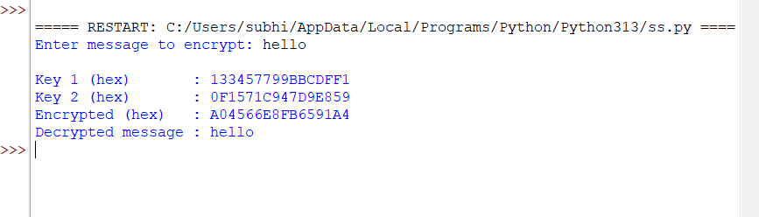
RESULT:
Thus the Double DES (2DES) encryption technique was implemented successfully using Python.

EX. NO: 13 IMPLEMENTATION OF 3DES
AIM:
To write a Python program to implement Triple DES (3DES) using the Encrypt-Decrypt-Encrypt (EDE) scheme with two keys.
DESCRIPTION:
Triple DES strengthens DES by applying the DES algorithm three times to each block using two keys, in the Encrypt-Decrypt-Encrypt (EDE) order: C = E(K1, D(K2, E(K1, P))). Using a decryption for the middle stage keeps 3DES backward compatible with single DES when K1 = K2, and the effective key length of about 112 bits (with two keys) makes brute-force attacks far harder than on single or double DES.
ALGORITHM:
STEP-1: Read the plain text message from the user, and fix two 64-bit keys K1 and K2.
STEP-2: Encrypt the plain text block with K1, then decrypt that result with K2.
STEP-3: Encrypt the result of Step 2 again with K1 to obtain the final cipher text block.
STEP-4: Repeat Steps 2-3 for every 8-byte block of the (padded) message to build the complete cipher text.
STEP-5: To decrypt, reverse the process - decrypt with K1, encrypt with K2, decrypt with K1 - and remove the padding to recover the original message.
PROGRAM: (Implementation of 3DES - Python)
# Experiment No: 13
# Implementation of 3DES (Triple DES - EDE mode)

IP = [58,50,42,34,26,18,10,2,60,52,44,36,28,20,12,4,
62,54,46,38,30,22,14,6,64,56,48,40,32,24,16,8,
57,49,41,33,25,17,9,1,59,51,43,35,27,19,11,3,
61,53,45,37,29,21,13,5,63,55,47,39,31,23,15,7]
FP = [40,8,48,16,56,24,64,32,39,7,47,15,55,23,63,31,
38,6,46,14,54,22,62,30,37,5,45,13,53,21,61,29,
36,4,44,12,52,20,60,28,35,3,43,11,51,19,59,27,
34,2,42,10,50,18,58,26,33,1,41,9,49,17,57,25]
E = [32,1,2,3,4,5,4,5,6,7,8,9,8,9,10,11,12,13,12,13,14,15,16,17,
16,17,18,19,20,21,20,21,22,23,24,25,24,25,26,27,28,29,28,29,30,31,32,1]
P = [16,7,20,21,29,12,28,17,1,15,23,26,5,18,31,10,
2,8,24,14,32,27,3,9,19,13,30,6,22,11,4,25]
PC1 = [57,49,41,33,25,17,9,1,58,50,42,34,26,18,
10,2,59,51,43,35,27,19,11,3,60,52,44,36,
63,55,47,39,31,23,15,7,62,54,46,38,30,22,
14,6,61,53,45,37,29,21,13,5,28,20,12,4]
PC2 = [14,17,11,24,1,5,3,28,15,6,21,10,23,19,12,4,26,8,
16,7,27,20,13,2,41,52,31,37,47,55,30,40,51,45,33,48,
44,49,39,56,34,53,46,42,50,36,29,32]
SHIFTS = [1,1,2,2,2,2,2,2,1,2,2,2,2,2,2,1]
SBOX = [
[[14,4,13,1,2,15,11,8,3,10,6,12,5,9,0,7],[0,15,7,4,14,2,13,1,10,6,12,11,9,5,3,8],
[4,1,14,8,13,6,2,11,15,12,9,7,3,10,5,0],[15,12,8,2,4,9,1,7,5,11,3,14,10,0,6,13]],
[[15,1,8,14,6,11,3,4,9,7,2,13,12,0,5,10],[3,13,4,7,15,2,8,14,12,0,1,10,6,9,11,5],
[0,14,7,11,10,4,13,1,5,8,12,6,9,3,2,15],[13,8,10,1,3,15,4,2,11,6,7,12,0,5,14,9]],
[[10,0,9,14,6,3,15,5,1,13,12,7,11,4,2,8],[13,7,0,9,3,4,6,10,2,8,5,14,12,11,15,1],
[13,6,4,9,8,15,3,0,11,1,2,12,5,10,14,7],[1,10,13,0,6,9,8,7,4,15,14,3,11,5,2,12]],
[[7,13,14,3,0,6,9,10,1,2,8,5,11,12,4,15],[13,8,11,5,6,15,0,3,4,7,2,12,1,10,14,9],
[10,6,9,0,12,11,7,13,15,1,3,14,5,2,8,4],[3,15,0,6,10,1,13,8,9,4,5,11,12,7,2,14]],
[[2,12,4,1,7,10,11,6,8,5,3,15,13,0,14,9],[14,11,2,12,4,7,13,1,5,0,15,10,3,9,8,6],
[4,2,1,11,10,13,7,8,15,9,12,5,6,3,0,14],[11,8,12,7,1,14,2,13,6,15,0,9,10,4,5,3]],
[[12,1,10,15,9,2,6,8,0,13,3,4,14,7,5,11],[10,15,4,2,7,12,9,5,6,1,13,14,0,11,3,8],
[9,14,15,5,2,8,12,3,7,0,4,10,1,13,11,6],[4,3,2,12,9,5,15,10,11,14,1,7,6,0,8,13]],
[[4,11,2,14,15,0,8,13,3,12,9,7,5,10,6,1],[13,0,11,7,4,9,1,10,14,3,5,12,2,15,8,6],
[1,4,11,13,12,3,7,14,10,15,6,8,0,5,9,2],[6,11,13,8,1,4,10,7,9,5,0,15,14,2,3,12]],
[[13,2,8,4,6,15,11,1,10,9,3,14,5,0,12,7],[1,15,13,8,10,3,7,4,12,5,6,11,0,14,9,2],
[7,11,4,1,9,12,14,2,0,6,10,13,15,3,5,8],[2,1,14,7,4,10,8,13,15,12,9,0,3,5,6,11]],
]

def permute(bits, table):
return [bits[i-1] for i in table]

def xor(a, b):
return [x ^ y for x, y in zip(a, b)]

def bytes_to_bits(b):
return [int(bit) for byte in b for bit in format(byte, '08b')]

def bits_to_bytes(bits):
out = bytearray()
for i in range(0, len(bits), 8):
byte = 0
for bit in bits[i:i+8]:
byte = (byte << 1) | bit
out.append(byte)
return bytes(out)

def generate_subkeys(key64):
key56 = permute(key64, PC1)
c, d = key56[:28], key56[28:]
subkeys = []
for shift in SHIFTS:
c = c[shift:] + c[:shift]
d = d[shift:] + d[:shift]
subkeys.append(permute(c + d, PC2))
return subkeys

def feistel(r, subkey):
x = xor(permute(r, E), subkey)
out = []
for i in range(8):
b6 = x[i*6:(i+1)*6]
row = b6[0]*2 + b6[5]
col = b6[1]*8 + b6[2]*4 + b6[3]*2 + b6[4]
out += [int(b) for b in format(SBOX[i][row][col], '04b')]
return permute(out, P)

def des_block(block8, key8, decrypt=False):
bits = permute(bytes_to_bits(block8), IP)
subkeys = generate_subkeys(bytes_to_bits(key8))
if decrypt:
subkeys = subkeys[::-1]
l, r = bits[:32], bits[32:]
for sk in subkeys:
l, r = r, xor(l, feistel(r, sk))
return bits_to_bytes(permute(r + l, FP))

def pad(data):
n = 8 - (len(data) % 8)
return data + bytes([n]) * n

def unpad(data):
return data[:-data[-1]]

def triple_des_encrypt(message, k1, k2):
data = pad(message.encode())
out = b""
for i in range(0, len(data), 8):
block = data[i:i+8]
step1 = des_block(block, k1) # Encrypt with K1
step2 = des_block(step1, k2, decrypt=True) # Decrypt with K2
step3 = des_block(step2, k1) # Encrypt with K1
out += step3
return out

def triple_des_decrypt(cipher, k1, k2):
out = b""
for i in range(0, len(cipher), 8):
block = cipher[i:i+8]
step1 = des_block(block, k1, decrypt=True) # Decrypt with K1
step2 = des_block(step1, k2) # Encrypt with K2
step3 = des_block(step2, k1, decrypt=True) # Decrypt with K1
out += step3
return unpad(out).decode()

key1 = bytes.fromhex("133457799BBCDFF1") # first 64-bit key
key2 = bytes.fromhex("0F1571C947D9E859") # second 64-bit key
message = input("Enter message to encrypt: ")
cipher = triple_des_encrypt(message, key1, key2)
decrypted = triple_des_decrypt(cipher, key1, key2)
print("\nKey 1 (hex) :", key1.hex().upper())
print("Key 2 (hex) :", key2.hex().upper())
print("Encrypted (hex) :", cipher.hex().upper())
print("Decrypted message :", decrypted)
OUTPUT:
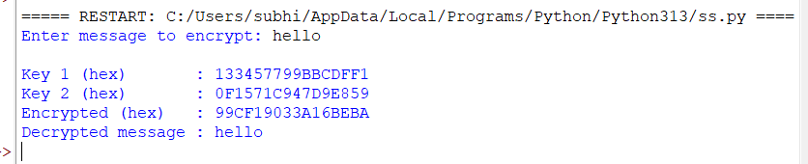
RESULT:
Thus the Triple DES (3DES) encryption technique was implemented successfully using Python.

EX. NO: 14 IMPLEMENTATION OF MODES OF DES - ALL TYPES
AIM:
To write a Python program to implement the different modes of operation of the DES algorithm - ECB, CBC, CFB, OFB and CTR.
DESCRIPTION:
A block cipher such as DES only defines how to encrypt a single fixed-size block, so a mode of operation describes how to apply it to messages of arbitrary length. Electronic Code Book (ECB) encrypts each block independently; Cipher Block Chaining (CBC) XORs each plain text block with the previous cipher text block before encryption; Cipher/Output Feedback (CFB/OFB) turn the block cipher into a stream cipher by repeatedly encrypting a shift register; and Counter (CTR) mode encrypts successive counter values to generate a keystream that is XORed with the plain text.
ALGORITHM:
STEP-1: Read the plain text message from the user, and fix a 64-bit key and an initialisation vector (IV).
STEP-2: For ECB mode, pad and encrypt each 8-byte block independently with the key.
STEP-3: For CBC mode, XOR each plain text block with the previous cipher block (or IV for the first block) before encrypting with the key.
STEP-4: For CFB and OFB modes, encrypt the IV/feedback value with the key to generate a keystream block and XOR it with the plain text block; OFB feeds back the keystream, CFB feeds back the cipher text.
STEP-5: For CTR mode, encrypt successive counter values (derived from the nonce) with the key to generate the keystream and XOR it with the plain text; display the resulting cipher text for all five modes.
PROGRAM: (Implementation of MODES OF DES - ALL TYPES - Python)
# Experiment No: 14
# Implementation of Modes of DES - ECB, CBC, CFB, OFB, CTR

IP = [58,50,42,34,26,18,10,2,60,52,44,36,28,20,12,4,
62,54,46,38,30,22,14,6,64,56,48,40,32,24,16,8,
57,49,41,33,25,17,9,1,59,51,43,35,27,19,11,3,
61,53,45,37,29,21,13,5,63,55,47,39,31,23,15,7]
FP = [40,8,48,16,56,24,64,32,39,7,47,15,55,23,63,31,
38,6,46,14,54,22,62,30,37,5,45,13,53,21,61,29,
36,4,44,12,52,20,60,28,35,3,43,11,51,19,59,27,
34,2,42,10,50,18,58,26,33,1,41,9,49,17,57,25]
E = [32,1,2,3,4,5,4,5,6,7,8,9,8,9,10,11,12,13,12,13,14,15,16,17,
16,17,18,19,20,21,20,21,22,23,24,25,24,25,26,27,28,29,28,29,30,31,32,1]
P = [16,7,20,21,29,12,28,17,1,15,23,26,5,18,31,10,
2,8,24,14,32,27,3,9,19,13,30,6,22,11,4,25]
PC1 = [57,49,41,33,25,17,9,1,58,50,42,34,26,18,
10,2,59,51,43,35,27,19,11,3,60,52,44,36,
63,55,47,39,31,23,15,7,62,54,46,38,30,22,
14,6,61,53,45,37,29,21,13,5,28,20,12,4]
PC2 = [14,17,11,24,1,5,3,28,15,6,21,10,23,19,12,4,26,8,
16,7,27,20,13,2,41,52,31,37,47,55,30,40,51,45,33,48,
44,49,39,56,34,53,46,42,50,36,29,32]
SHIFTS = [1,1,2,2,2,2,2,2,1,2,2,2,2,2,2,1]
SBOX = [
[[14,4,13,1,2,15,11,8,3,10,6,12,5,9,0,7],[0,15,7,4,14,2,13,1,10,6,12,11,9,5,3,8],
[4,1,14,8,13,6,2,11,15,12,9,7,3,10,5,0],[15,12,8,2,4,9,1,7,5,11,3,14,10,0,6,13]],
[[15,1,8,14,6,11,3,4,9,7,2,13,12,0,5,10],[3,13,4,7,15,2,8,14,12,0,1,10,6,9,11,5],
[0,14,7,11,10,4,13,1,5,8,12,6,9,3,2,15],[13,8,10,1,3,15,4,2,11,6,7,12,0,5,14,9]],
[[10,0,9,14,6,3,15,5,1,13,12,7,11,4,2,8],[13,7,0,9,3,4,6,10,2,8,5,14,12,11,15,1],
[13,6,4,9,8,15,3,0,11,1,2,12,5,10,14,7],[1,10,13,0,6,9,8,7,4,15,14,3,11,5,2,12]],
[[7,13,14,3,0,6,9,10,1,2,8,5,11,12,4,15],[13,8,11,5,6,15,0,3,4,7,2,12,1,10,14,9],
[10,6,9,0,12,11,7,13,15,1,3,14,5,2,8,4],[3,15,0,6,10,1,13,8,9,4,5,11,12,7,2,14]],
[[2,12,4,1,7,10,11,6,8,5,3,15,13,0,14,9],[14,11,2,12,4,7,13,1,5,0,15,10,3,9,8,6],
[4,2,1,11,10,13,7,8,15,9,12,5,6,3,0,14],[11,8,12,7,1,14,2,13,6,15,0,9,10,4,5,3]],
[[12,1,10,15,9,2,6,8,0,13,3,4,14,7,5,11],[10,15,4,2,7,12,9,5,6,1,13,14,0,11,3,8],
[9,14,15,5,2,8,12,3,7,0,4,10,1,13,11,6],[4,3,2,12,9,5,15,10,11,14,1,7,6,0,8,13]],
[[4,11,2,14,15,0,8,13,3,12,9,7,5,10,6,1],[13,0,11,7,4,9,1,10,14,3,5,12,2,15,8,6],
[1,4,11,13,12,3,7,14,10,15,6,8,0,5,9,2],[6,11,13,8,1,4,10,7,9,5,0,15,14,2,3,12]],
[[13,2,8,4,6,15,11,1,10,9,3,14,5,0,12,7],[1,15,13,8,10,3,7,4,12,5,6,11,0,14,9,2],
[7,11,4,1,9,12,14,2,0,6,10,13,15,3,5,8],[2,1,14,7,4,10,8,13,15,12,9,0,3,5,6,11]],
]

def permute(bits, table):
return [bits[i-1] for i in table]

def xor(a, b):
return [x ^ y for x, y in zip(a, b)]

def bytes_to_bits(b):
return [int(bit) for byte in b for bit in format(byte, '08b')]

def bits_to_bytes(bits):
out = bytearray()
for i in range(0, len(bits), 8):
byte = 0
for bit in bits[i:i+8]:
byte = (byte << 1) | bit
out.append(byte)
return bytes(out)

def generate_subkeys(key64):
key56 = permute(key64, PC1)
c, d = key56[:28], key56[28:]
subkeys = []
for shift in SHIFTS:
c = c[shift:] + c[:shift]
d = d[shift:] + d[:shift]
subkeys.append(permute(c + d, PC2))
return subkeys

def feistel(r, subkey):
x = xor(permute(r, E), subkey)
out = []
for i in range(8):
b6 = x[i*6:(i+1)*6]
row = b6[0]*2 + b6[5]
col = b6[1]*8 + b6[2]*4 + b6[3]*2 + b6[4]
out += [int(b) for b in format(SBOX[i][row][col], '04b')]
return permute(out, P)

def des_block(block8, key8, decrypt=False):
bits = permute(bytes_to_bits(block8), IP)
subkeys = generate_subkeys(bytes_to_bits(key8))
if decrypt:
subkeys = subkeys[::-1]
l, r = bits[:32], bits[32:]
for sk in subkeys:
l, r = r, xor(l, feistel(r, sk))
return bits_to_bytes(permute(r + l, FP))

def pad(data):
n = 8 - (len(data) % 8)
return data + bytes([n]) * n

def unpad(data):
return data[:-data[-1]]

def ecb_encrypt(data, key):
data = pad(data)
return b"".join(des_block(data[i:i+8], key) for i in range(0, len(data), 8))

def cbc_encrypt(data, key, iv):
data = pad(data)
out, prev = b"", iv
for i in range(0, len(data), 8):
block = bytes(a ^ b for a, b in zip(data[i:i+8], prev))
enc = des_block(block, key)
out += enc
prev = enc
return out

def cfb_encrypt(data, key, iv):
out, prev = b"", iv
for i in range(0, len(data), 8):
chunk = data[i:i+8]
keystream = des_block(prev, key)[:len(chunk)]
enc = bytes(a ^ b for a, b in zip(chunk, keystream))
out += enc
prev = enc.ljust(8, b"\x00")
return out

def ofb_encrypt(data, key, iv):
out, feedback = b"", iv
for i in range(0, len(data), 8):
chunk = data[i:i+8]
feedback = des_block(feedback, key)
out += bytes(a ^ b for a, b in zip(chunk, feedback[:len(chunk)]))
return out

def ctr_encrypt(data, key, nonce):
out, counter = b"", 0
for i in range(0, len(data), 8):
chunk = data[i:i+8]
ctr_block = (int.from_bytes(nonce, "big") + counter).to_bytes(8, "big")
keystream = des_block(ctr_block, key)
out += bytes(a ^ b for a, b in zip(chunk, keystream[:len(chunk)]))
counter += 1
return out

key = bytes.fromhex("133457799BBCDFF1") # 64-bit secret key
iv = bytes.fromhex("0000000000000000") # initialisation vector / nonce
message = input("Enter message: ").encode()

print("\nECB Mode :", ecb_encrypt(message, key).hex().upper())
print("CBC Mode :", cbc_encrypt(message, key, iv).hex().upper())
print("CFB Mode :", cfb_encrypt(message, key, iv).hex().upper())
print("OFB Mode :", ofb_encrypt(message, key, iv).hex().upper())
print("CTR Mode :", ctr_encrypt(message, key, iv).hex().upper())
OUTPUT:
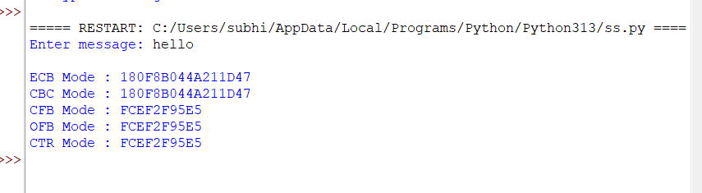
RESULT:
Thus the ECB, CBC, CFB, OFB and CTR modes of operation of the DES algorithm were implemented successfully using Python.
EX. NO: 15 IMPLEMENTATION OF RSA
AIM:
To write a Python program to implement the RSA encryption algorithm.
DESCRIPTION:
RSA is an asymmetric cryptographic algorithm built around a public key, used for encryption, and a private key, used for decryption. Two large prime numbers p and q are chosen and multiplied to form the modulus n, Euler's totient phi(n) = (p-1)(q-1) is computed, and a public exponent e that is co-prime to phi(n) is selected. The private exponent d is then the modular inverse of e modulo phi(n), so that (m^e)^d = m (mod n) for every message m.
ALGORITHM:
STEP-1: Read two prime numbers, p and q, from the user and verify that both are prime and distinct.
STEP-2: Compute the modulus n = p * q and Euler's totient phi(n) = (p-1) * (q-1).
STEP-3: Select a public exponent e that is co-prime to phi(n), and compute the private exponent d as the modular inverse of e modulo phi(n).
STEP-4: Encrypt each character of the message as (character value)^e mod n to obtain the cipher text.
STEP-5: Decrypt each cipher value as (cipher value)^d mod n to recover the original message.
PROGRAM: (Implementation of RSA - Python)
# Experiment No: 15
# Implementation of RSA

import math

def is_prime(n):
if n < 2:
return False
for i in range(2, int(math.isqrt(n)) + 1):
if n % i == 0:
return False
return True

p = int(input("ENTER FIRST PRIME NUMBER\n"))
q = int(input("ENTER ANOTHER PRIME NUMBER\n"))
if not (is_prime(p) and is_prime(q)) or p == q:
print("WRONG INPUT")
exit()

msg = input("ENTER MESSAGE\n")

n = p * q
phi = (p - 1) * (q - 1)

# choose e coprime to phi
e = 2
while e < phi:
if math.gcd(e, phi) == 1:
break
e += 1
d = pow(e, -1, phi) # modular inverse

print("\nPUBLIC KEY (e, n):", (e, n))
print("PRIVATE KEY (d, n):", (d, n))

encrypted = [pow(ord(ch), e, n) for ch in msg]
print("\nTHE ENCRYPTED MESSAGE IS (numeric form)")
print(encrypted)

decrypted = "".join(chr(pow(c, d, n)) for c in encrypted)
print("\nTHE DECRYPTED MESSAGE IS")
print(decrypted)
OUTPUT:
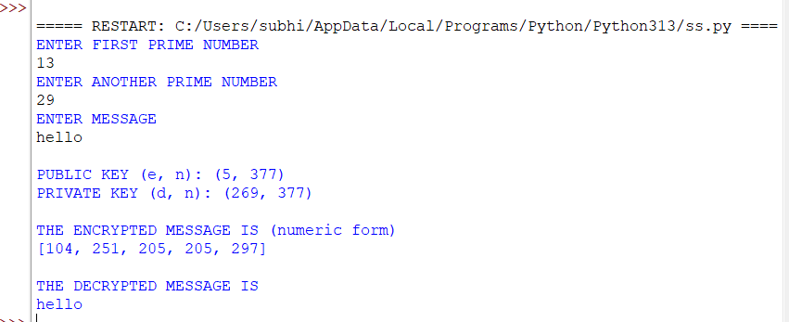
RESULT:
Thus the RSA encryption technique was implemented successfully using Python.

EX. NO: 16 IMPLEMENTATION OF DIFFIE-HELLMAN KEY EXCHANGE ALGORITHM
AIM:
To implement the Diffie-Hellman Key Exchange algorithm using a Python program.
DESCRIPTION:
The Diffie-Hellman algorithm allows two parties to establish a shared secret key over an insecure channel without ever transmitting the key itself. Both parties agree on a public prime n and a public base g. Each party then chooses a private random number, computes a public value using modular exponentiation, and exchanges these public values. Both parties can then independently compute the same shared secret key using their own private value and the public value received from the other party.
ALGORITHM:
STEP-1: Both parties agree on and share the public values n (a prime) and g (a base).
STEP-2: The first party selects a private value x and computes the public value A = g^x mod n, which is sent to the second party.
STEP-3: The second party selects a private value y and computes the public value B = g^y mod n, which is sent to the first party.
STEP-4: The first party computes the shared secret key as B^x mod n.
STEP-5: The second party computes the shared secret key as A^y mod n; both results are equal, giving the shared secret key.
PROGRAM: (Implementation of DIFFIE-HELLMAN KEY EXCHANGE ALGORITHM - Python)
# Experiment No: 16
# Implementation of Diffie-Hellman Key Exchange Algorithm

n = int(input("Enter the value of n : "))
g = int(input("Enter the value of g : "))

x = int(input("Enter the value of x for the first person : "))
a = pow(g, x, n)

y = int(input("Enter the value of y for the second person : "))
b = pow(g, y, n)

key_first = pow(b, x, n)
key_second = pow(a, y, n)

print("\nA (public value sent by first person) :", a)
print("B (public value sent by second person) :", b)
print("\nKey for the first person is :", key_first)
print("Key for the second person is :", key_second)
OUTPUT:
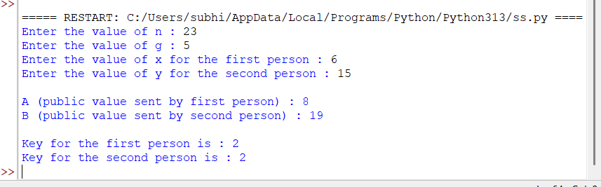
RESULT:
Thus the Diffie-Hellman key exchange algorithm was successfully implemented using Python.

EX. NO: 17 IMPLEMENTATION OF ECC
AIM:
To write a Python program to implement Elliptic Curve Cryptography (ECC) based key exchange (ECDH).
DESCRIPTION:
Elliptic Curve Cryptography works with points on an elliptic curve of the form y^2 = x^3 + ax + b (mod p) instead of large integers, using point addition and scalar (point) multiplication as its core operations. Because the elliptic curve discrete logarithm problem - recovering k given a point P and the point k*P - is computationally hard, ECC achieves security comparable to RSA using much smaller key sizes. In Elliptic Curve Diffie-Hellman (ECDH), each party picks a private integer, computes its public point by multiplying a shared base point G by that integer, exchanges public points, and each independently multiplies the other's public point by its own private key to arrive at the same shared secret point.
ALGORITHM:
STEP-1: Fix the elliptic curve parameters a, b and prime p, and the base point G on the curve y^2 = x^3 + ax + b (mod p).
STEP-2: Read the private keys of person A and person B from the user.
STEP-3: Compute each person's public key by multiplying the base point G by their private key, using point addition and doubling (scalar multiplication).
STEP-4: Exchange the public keys, and have each person multiply the other person's public key by their own private key.
STEP-5: Display the shared secret point computed by both persons and verify that the two results match.
PROGRAM: (Implementation of ECC - Python)
# Experiment No: 17
# Implementation of ECC (Elliptic Curve Diffie-Hellman)

def inverse_mod(k, p):
return pow(k, -1, p)

def point_add(P1, P2, a, p):
if P1 is None:
return P2
if P2 is None:
return P1
x1, y1 = P1
x2, y2 = P2
if x1 == x2 and (y1 + y2) % p == 0:
return None
if P1 == P2:
m = (3 * x1 * x1 + a) * inverse_mod(2 * y1, p) % p
else:
m = (y2 - y1) * inverse_mod(x2 - x1, p) % p
x3 = (m * m - x1 - x2) % p
y3 = (m * (x1 - x3) - y1) % p
return (x3, y3)

def scalar_mult(k, P, a, p):
result = None
addend = P
while k:
if k & 1:
result = point_add(result, addend, a, p)
addend = point_add(addend, addend, a, p)
k >>= 1
return result

# Curve: y^2 = x^3 + a*x + b (mod p), base point G
a, b, p = 2, 2, 17
G = (5, 1)

priv_A = int(input("Enter private key for person A : "))
priv_B = int(input("Enter private key for person B : "))

pub_A = scalar_mult(priv_A, G, a, p)
pub_B = scalar_mult(priv_B, G, a, p)

shared_A = scalar_mult(priv_A, pub_B, a, p)
shared_B = scalar_mult(priv_B, pub_A, a, p)

print("\nCurve: y^2 = x^3 + %dx + %d (mod %d), Base Point G = %s" % (a, b, p, G))
print("Public Key A :", pub_A)
print("Public Key B :", pub_B)
print("\nShared Secret Key (computed by A) :", shared_A)
print("Shared Secret Key (computed by B) :", shared_B)
OUTPUT:
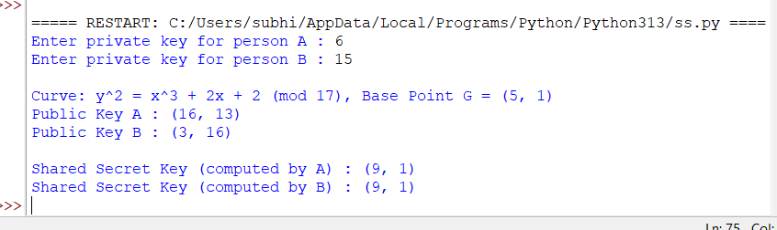
RESULT:
Thus the Elliptic Curve Cryptography (ECC) based key exchange algorithm was implemented successfully using Python.

